A lens essay is a type of comparative paper that analyzes one text through the viewpoints expressed in another. Generally, the lens should reveal something original about the “target” text. Alternatively, your analysis may call the validity of the arguments of the lens piece into question, extend the arguments of the lens text, or provoke some other reevaluation of the two texts. Either way, you will be generating a critical dialogue between texts.

How to write a “lens” essay:

First, read the lens text to identify the author’s core arguments and vocabulary. Since theoretical or critical texts tend to be dense and complex, it may be helpful to develop an outline of the author’s primary points.

Next, read/view/listen to the target text to develop a general idea of its content, ask yourself:

- Where do I see general points of agreement or disagreement between the two texts?
- Which of the lens text’s main arguments could be applied to the target text?

Focus on one (or two) of the lens text’s central arguments. This is a complicated form so keep the content tightly focused.

With these ideas in mind, go back and read/listen to/ view the target text carefully, through the theoretical lens, ask yourself the following question: What are the main components of the lens text and what are their complementary parts in the target text?

For each point of the lens text there should be a complementary point in the target text (this will be the main content for your body paragraphs). For example, maybe you’re using Wainaina’s “How to Write about Africa” as a lens and Die Antwoord’s “Fatty Boom Boom” as a target text. You’ve decided that the overall message of Wainaina’s text is that western media portrays Africa and Africans in a way that perpetuates a feeling of superiority in the West over Africa(ns). You’ve chosen an example from the Wainaina text that details the types of African people (stereotypes) portrayed by western media. After you’ve explained why/how the representation of the people in the Wainaina text supports his main argument (western feelings of superiority), look to the Die Antwoord video for a complementary point. Are the people in the video depicted in a similar or different way? Are they stereotypical depictions or everyday people? Does the representation of people in the Die Antwoord text align with or contradict Wainaina’s point?

Then move to another example—maybe animals or celebrities, and do the same thing. There are no set number of examples that you have to choose. You could do an in-depth exploration of one point; however, three—I think—is the most you could adequately develop in an essay this length.

A few notes: Remember to try to apply the lens author’s theoretical vocabulary or logic to instances in the target text. Use the language of the lens text to contextualize the target. The lens author is making an argument. They’ve carefully chosen vocabulary to express and support that argument. Why not benefit from their hard work? Look at, and borrow, their language. Quote short phrases, use their verbs, and even borrow short, specialized phrases.
Using the language of the target text will align your own essay with both tone and content of the foundation work. This is a good thing. For example, Wainaina opens with an appeal, “[a]lways use the word ‘Africa’ or ‘Darkness’ or ‘Safari’ in your title.” Is there a moment in the Die Antwoord video that this language can be directly linked to?

You could also note whether there are instances where the lens text’s arguments don’t or can’t apply. Each lens/target pairing may express the same relationship or it might be different. That’s fine. It’s very rare that texts will be totally compatible. Just be sure to clearly explain each relationship.

Can you identify a place where the texts are in conflict with each other?

Writing the introduction and thesis: As your paper concerns the complex interactions between multiple texts, it is important to explain what you will be doing in the introduction. The introduction should:

- clearly introduce the lens text and the specific argument(s) you will be employing or evaluating;
- introduce the target text and the specific theme(s) or event(s) you will be addressing in your analysis.

These introductions of texts and themes should lead into a thesis statement. Make sure the thesis statement identifies the main points of interaction you will be discussing, and explains what your critical or theoretical analysis of the lens text reveals about the target text(s).

Frames in the body: This is a complex essay, so it needs to be very tightly organized. Using frames for main topic sentences of body paragraphs is an excellent way to maintain organization in the text. A frame might look something like this: The Wainaina (lens) text states X / that is extended/contradicted /redefined/supported by Y in the target text by/because (give your reason for the stated relationship). Frames should be varied so the essay isn’t repetitive, but there should be a clear statement of relationship in/near the beginning of every comparative section. The last sentence of each body section should refer directly back to your thesis statement. How does the section you’ve just completed relate to your argument in the thesis statement?

Note: Section doesn’t mean paragraph. You may have a lot of content in a section; it may take you two or three paragraphs to fully explain and compare the identified content. Frames are for the main topic sentence. Within sections, you can use transition words to indicate that you’re still engaged in the same discussion.

Conclusion: The conclusion of the paper should do what conclusions do. That is, restate the thesis; summarize all the main points from the body; then you can discuss the implications of the texts or offer a solution to the “problem” defined by your critical analysis. The conclusion is always a little more flexible, but the restatement of thesis and summary of main body points are required elements.
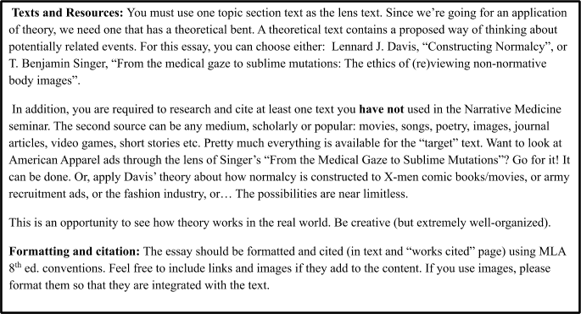

1000-1200 words DUE DATES:
PROPOSAL by OCTOBER 21st FIRST DRAFT by NOVEMBER 4th
PEER REVIEW by NOVEMBER

11th

FINAL DRAFT by NOVEMBER

18th

Critical lens rubric

Levels of Achievement

Criteria | Questions
Content | 1 to 25 points  Does the thesis statement clearly describe the points of interaction between the "lens" and "target" texts? Is the main argument of the "lens" essay fully explained? Is the "lens" essay's main argument present in the analysis of each point of the "target" text? Is the "lens" author’s theoretical vocabulary or logic applied to specific instances in the "target" text? Is the relationship between each lens/target pair clearly stated?
Development | 1 to 25 points  Is each point of comparison fully explored with regard to how the "target" relates to the lens or vice versa? Is the "lens" text fully described? Is each "target" text example explicitly specifically connected to the "lens"? Is there wide use of specific evidence from each text? Is each point connected back to the thesis statement in some way?
Structure and Organization | 1 to 25 points  Does the introduction clearly introduce the lens text and the specific arguments you will be employing or evaluating? Does the introduction present the target text and specific themes or events you will be addressing in your analysis? Do all main body sections open with strong topic sentences that state the main idea and describe the relationship that will be discussed in the section? Do the body paragraphs maintain the focus established by the critical lens? Are supplementary body paragraphs connected with transitions? Does the conclusion restate the thesis and summarize information presented in the body? Does the conclusion connect to a larger context by discussing the implications of the lens/target pair?
Language Use | 1 to 15 points  Is language stylistically diverse? Is diction precise, accurate, and economical? Are sentences stylistically diverse?

Mechanics | 1 to 10 points  Is there good control of grammatical conventions? Are MLA conventions appropriately used in both text and in the "works cited" section? If images are present, are they formatted appropriately? Does the essay conform to the requirements of the assignment?

